Marathwada Mitra Mandal’s
College of Engineering, Pune
Karve Nagar, Pune-411 052


Department of Computer Engineering

Lab Manual
Lab Practice II
Artificial Intelligence
TE COMPUTER

Prepared by:
Prof. Swati Shekapure

310258:Laboratory Practice II(Artificial Intelligence)
- Course Outcome
Course Outcome | Statement
 | At the end of the course, student will be able to
1 | Design a system using different informed search / uninformed search or heuristic approaches
2 | Apply basic principles of AI in solutions that require problem solving, inference, perception, knowledge representation, and learning
3 | Design and develop an interactive AI application

- CO-PO Mapping (Levels :1-Low , 2-Medium, 3-High)
Course Outcome | Program outcomes
 | 1 | 2 | 3 | 4 | 5 | 6 | 7 | 8 | 9 | 10 | 11 | 12
310258.1 | 2 | - | 2 |  | 3 |  |  | 2 | 2 | 2 | 1 | 2
310258.2 | 1 | - | 2 | 2 | 3 | 2 |  | 2 | 2 | 2 | 1 | 2
310258.3 | 1 | - | 2 | 2 | 3 | 2 |  | 2 | 2 | 2 | 2 | 2
CO-PSO mapping
Course Outcome | Program Specific Outcomes
 | 1 | 2
310258.1 | 2 | 1
310258.2 | 1 | 2
310258.3 | 2 | 1

Semester II Academic Year 2021-22

INDEX

Sr.  No. | Group | Title of Assignment | CO | PO
1 | A | Implement depth first search algorithm and Breadth First Search algorithm, Use an undirected graph and develop a recursive algorithm for searching all the vertices of a graph or tree data structure. | 1 | PO1,3,5,8,9,10,11,12  PSO:1,2
2 | A | Implement A star Algorithm for 8-Puzzle search problem. | 1 | PO1,3,5,8,9,10,11,12  PSO:1,2
3 | A | Part I: Implement Greedy search algorithm for Job Scheduling Problem  Part II: Implement Greedy search algorithm for Dijkstra's Minimum Spanning Tree Algorithm | 1 | PO1,3,5,8,9,10,11,12  PSO:1,2
4 | B | Implement a solution for a Constraint Satisfaction Problem using Branch and Bound and Backtracking for n-queens problem or a graph coloring problem. | 2 | PO1,3,4,5,6,8,9,10,11,12  PSO:1,2
5 | B | Develop an elementary chatbot for any suitable customer interaction application. | 3 | PO1,3,4,5,6,8,9,10,11,12  PSO:1,2
6 | C | Implement Expert System  for Hospitals and medical facilities | 3 | PO1,3,4,5,6,8,9,10,11,12  PSO:1,2
7 | Content Beyond Syllabus | Implement Tic-Tac -Toe using Min Max Algorithm | 2 | PO1,3,4,5,6,8,9,10,11,12  PSO:1,2

Program Outcomes (POs)
Engineering Graduates will be able to:
1. Engineering Knowledge: Apply the knowledge of mathematics, science, engineering fundamentals and an engineering specialization to the solution of complex engineering problems.
2. Problem Analysis: Identify, formulates, review research literature, and analyze complex engineering problems reaching substantiated conclusions using first principles of mathematics, natural sciences, and engineering sciences.
3. Design / development of solutions: Design solutions for complex engineering problems and design system components or processes that meet the specified needs with appropriate consideration for the public health and safety, and the cultural, societal, and environmental considerations.
4. Conduct investigations of complex problems: Use research – based knowledge and research methods including design of experiments, analysis and interpretation of data, and synthesis of the information to provide valid conclusions.
5. Modern tool usage: Create, select and apply appropriate techniques, resources, and modern engineering and IT tools including prediction and modeling to complex engineering activities with an understanding of the limitations.
6. The engineer and society: Apply reasoning informed by the contextual knowledge to assess societal, health, safety, legal and cultural issues and the consequent responsibilities relevant to the professional engineering practice.
7. Environment and sustainability: Understand the impact of the professional engineering solutions in societal and environmental contexts, and demonstrate the knowledge of, and need for sustainable development.
8. Ethics: Apply ethical principles and commit to professional ethics and responsibilities and norms of the engineering practice.
9. Individual and team work: Function effectively as an individual, and as a member or leader in diverse teams, and in multidisciplinary settings.
10. Communication: Communicate effectively on complex engineering activities with the engineering community and with society at large, such as, being able to comprehend and write effective reports and design documentation, make effective presentations, and give and receive clear instructions.
11. Project management and finance: Demonstrate knowledge and understanding of the engineering and management principles and apply these to one’s own work, as a member and leader in a team, to manage projects and in multidisciplinary environments.
12. Life-long learning: Recognize the need for, and have the preparation and ability to engage in independent and life-long learning in the broadest context of technological change.

Program Specific Outcomes (PSOs)
- A graduate of the Computer Engineering Program will be able to Attain proficiency in analyzing and applying Computer Engineering Fundamentals viz. algorithms, system softwares and networking for contemporary system development through advanced technologies like - Cyber Security, High Performance Computing and Data Analytics (Artificial Intelligence,Machine Learning) etc.
- Identify, formulate and solve real world problems in societal and environmental contexts through lifelong learning, entrepreneurship and leadership skills.

Assignment No. 1

TITLE: Implement depth first search algorithm and Breadth First Search algorithm, Use an undirected graph and develop a recursive algorithm for searching all the vertices of a graph or tree data structure.
OBJECTIVE: To learn and apply various search strategies for AI
OUTCOME: Design a system using different informed search / uninformed search or heuristic approaches

THEORY:
Uninformed search is a class of general-purpose search algorithms which operates in brute force-way. Uninformed search algorithms do not have additional information about state or search space other than how to traverse the tree, so it is also called blind search.
Following are the various types of uninformed search algorithms:
- Breadth-first Search
- Depth-first Search
- Depth-limited Search
- Iterative deepening depth-first search
- Uniform cost search
- Bidirectional Search

Breadth-first Search:
- Breadth-first search is the most common search strategy for traversing a tree or graph. This algorithm searches breadthwise in a tree or graph, so it is called breadth-first search.
- The BFS algorithm starts searching from the root node of the tree and expands all successor nodes at the current level before moving to nodes of the next level.
- The breadth-first search algorithm is an example of a general-graph search algorithm.
- Breadth-first search implemented using FIFO queue data structure.
Advantages:
- BFS will provide a solution if any solution exists.
- If there are more than one solutions for a given problem, then BFS will provide the minimal solution which requires the least number of steps.
Disadvantages:
- It requires lots of memory since each level of the tree must be saved into memory to expand the next level.
- BFS needs lots of time if the solution is far away from the root node.

Example:
In the below tree structure, we have shown the traversing of the tree using BFS algorithm from the root node S to goal node K. BFS search algorithm traverse in layers, so it will follow the path which is shown by the dotted arrow, and the traversed path will be:
- S---> A--->B---->C--->D---->G--->H--->E---->F---->I---->K
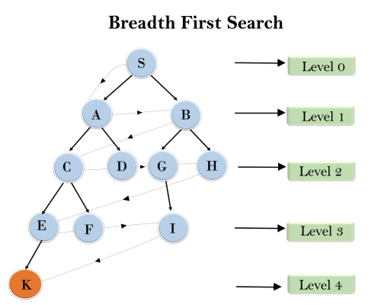
Time Complexity: Time Complexity of BFS algorithm can be obtained by the number of nodes traversed in BFS until the shallowest Node. Where the d= depth of shallowest solution and b is a node at every state.
T (b) = 1+b²+b³+.......+ b^{d}= O (b^{d})
Space Complexity: Space complexity of BFS algorithm is given by the Memory size of frontier which is O(b^{d}).
Completeness: BFS is complete, which means if the shallowest goal node is at some finite depth, then BFS will find a solution.
Optimality: BFS is optimal if path cost is a non-decreasing function of the depth of the node.

Depth-first Search
- Depth-first search is a recursive algorithm for traversing a tree or graph data structure.
- It is called the depth-first search because it starts from the root node and follows each path to its greatest depth node before moving to the next path.
- DFS uses a stack data structure for its implementation.
- The process of the DFS algorithm is similar to the BFS algorithm.
Advantage:
- DFS requires very less memory as it only needs to store a stack of the nodes on the path from root node to the current node.
- It takes less time to reach the goal node than the BFS algorithm (if it traverses in the right path).
Disadvantage:
- There is the possibility that many states keep reoccurring, and there is no guarantee of finding the solution.
- The DFS algorithm goes for deep down searching and sometimes it may go to the infinite loop.

Example:
In the below search tree, we have shown the flow of depth-first search, and it will follow the order as:
Root node--->Left node ----> right node.
It will start searching from root node S, and traverse A, then B, then D and E, after traversing E, it will backtrack the tree as E has no other successor and still the goal node is not found. After backtracking it will traverse node C and then G, and here it will terminate as it found the goal node.
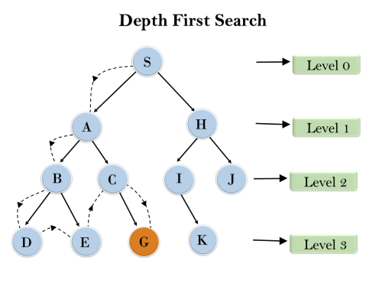
Completeness: DFS search algorithm is complete within finite state space as it will expand every node within a limited search tree.
Time Complexity: Time complexity of DFS will be equivalent to the node traversed by the algorithm. It is given by:
T(n)= 1+ b²+ b³ +.........+ b^{m}=O(b^{m})
Where, m= maximum depth of any node and this can be much larger than d (Shallowest solution depth)
Space Complexity: DFS algorithm needs to store only a single path from the root node, hence space complexity of DFS is equivalent to the size of the fringe set, which is O(bm).
Optimal: DFS search algorithm is non-optimal, as it may generate a large number of steps or high cost to reach the goal node.
CONCLUSION: Hence, We have Successfully Implemented Breadth first search and Depth first search

FAQS:

Q1. Define Artificial Intelligence (AI).
Answer: The study of how to make computers do things at which at the moment, people are better.
Systems that think like humans
Systems that act like humans
Systems that think rationally
Systems that act rationally

Q 2. What is meant by the Turing test?
Answer: To conduct this test we need two people and one machine. One person will be an interrogator
(i.e.) questioner, will be asking questions to one person and one machine. Three of them will be
in a separate room.
Interrogator knows them just as A and B. so it has to identify which is the person and
machine.
The goal of the machine is to make Interrogator believe that it is the person’s answer. If machine
succeeds by fooling the Interrogator, the machine acts like a human. Programming a computer to
passing the Turing test is very difficult.

Q 3. Define a problem solving agent.
Answer: Problem solving agent is one kind of goal based agent, where the agent Should select one action from a sequence of actions which lead to desirable states. The steps involved in simple problem solving techniques.
i. Goal formulation
ii. Problem formulation
iii. Search
iv. Solution
v. Execution phase

Q 4. Differentiate Blind Search and Heuristic Search.
Answer:
Blind search
i) No information about the path cost from the current state to goal state.
ii) Problem is solved with the information we know.
iii) Example a) Breadth first search b) Uniform cost search c) Depth first Search d) Depth limited search e) Iterative deepening search f) Bi – Directional Search
Heuristic search
i) We have some information like minimum path caused to move
ii) Problems can be solved by the information which is already given.
iii) Example a) Best first search b) Greedy search c) A* search

Q 5: What do you mean by Goal Based Agent?
Answer:The knowledge of the current state environment is not always sufficient to decide for an agent what to do.The agent needs to know its goal which describes desirable situations.Goal-based agents expand the capabilities of the model-based agent by having the "goal" information.They choose an action, so that they can achieve the goal.These agents may have to consider a long sequence of possible actions before deciding whether the goal is achieved or not. Such considerations of different scenarios are called searching and planning, which makes an agent proactive.

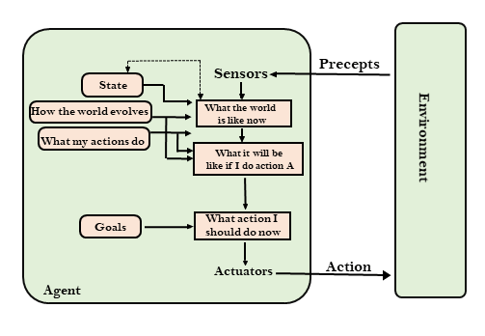

Assignment No. 2

TITLE: Implement A star Algorithm for 8-Puzzle search problem
OBJECTIVE: To learn and apply various search strategies for AI
OUTCOME: Design a system using different informed search / uninformed search or heuristic approaches
THEORY:
A* Algorithm is one of the best and most popular techniques used for path finding and graph traversals.A lot of games and web-based maps use this algorithm for finding the shortest path efficiently.It is essentially the best first search algorithm.
Working-
A* Algorithm works as-
- It maintains a tree of paths originating at the start node.
- It extends those paths one edge at a time.
- It continues until its termination criterion is satisfied.
A* Algorithm extends the path that minimizes the following function-
f(n) = g(n) + h(n)
Here,
- ‘n’ is the last node on the path
- g(n) is the cost of the path from start node to node ‘n’
- h(n) is a heuristic function that estimates cost of the cheapest path from node ‘n’ to the goal node
Algorithm
- The implementation of A* Algorithm involves maintaining two lists- OPEN and CLOSED.
- OPEN contains those nodes that have been evaluated by the heuristic function but have not been expanded into successors yet.
- CLOSED contains those nodes that have already been visited.
The algorithm is as follows
Step-01:
Define a list OPEN.
Initially, OPEN consists solely of a single node, the start node S.
Step-02:
If the list is empty, return failure and exit.
Step-03:
Remove node n with the smallest value of f(n) from OPEN and move it to list CLOSED.
If node n is a goal state, return success and exit.
Step-04:
Expand node n.
Step-05:
If any successor to n is the goal node, return success and the solution by tracing the path from goal node to S.
Otherwise, go to Step-06.
Step-06:
For each successor node,
Apply the evaluation function f to the node.
If the node has not been in either list, add it to OPEN.
Step-07:
Go back to Step-02.
Given an initial state of a 8-puzzle problem and final state to be reached-
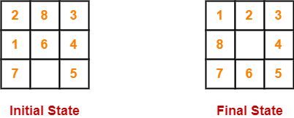
Find the most cost-effective path to reach the final state from initial state using A* Algorithms.
Consider g(n) = Depth of node and h(n) = Number of misplaced tiles.
Solution-

- A* Algorithm maintains a tree of paths originating at the initial state.
- It extends those paths one edge at a time.
- It continues until the final state is reached.

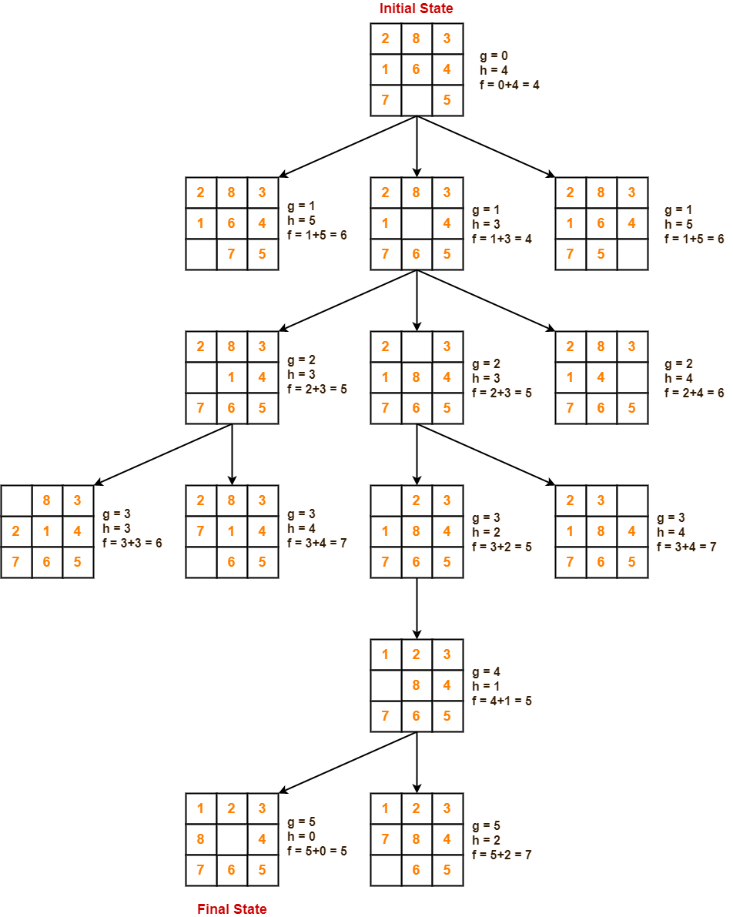
CONCLUSION:We have successfully implemented 8 puzzle problem using A* algorithm.

FAQS:

Q 1. What is informed search?
One that uses problems – specific knowledge beyond the definition of the problem itself and it can find solutions more efficiently than an uninformed strategy.

Q. 2. What is the use of QUEUING_FN?
QUEUING_FN inserts assets of elements into the queue. Different varieties of queuing fn produce different varieties of the search algorithm.

Q. 3. Mention the criteria for the evaluation of search strategy.
There are 4 criteria: Completeness, time complexity, space complexity, optimality

Q 4. What is Best First Search?
Best First Search is an instance of the general TREE SEARCH or GRAPH SEARCH algorithm in which a node is selected for expansion based on an evaluation function, f(n).

Q 5. Define Evaluation function, f(n)and h(n).
A node with the lowest evaluation is selected for expansion, because evaluation measures distance to the goal.
h (n) is defined as the estimated cost of the cheapest path from node n to a goal node.

Q 7. Define Greedy Best First Search.
It expands the node that is closest to the goal (i.e.) to reach a solution in a quicker way. It is done by using the heuristic function: f(n) = h(n).

Q 8. Define A* search.
A* search evaluates nodes by combining g(n), the cost to reach the node and h(n), the cost to get from the node to the goal.

Assignment No. 3

TITLE: Implement Greedy search algorithm for Job Scheduling Problem
OBJECTIVE: To learn and apply various search strategies for AI
OUTCOME: Design a system using different informed search / uninformed search or heuristic approaches
THEORY:
Job scheduling is the problem of scheduling jobs out of a set of N jobs on a single processor which maximizes profit as much as possible. Consider N jobs, each taking unit time for execution. Each job has some profit and deadline associated with it. Profit earned only if the job is completed on or before its deadline. Otherwise, we have to pay a profit as a penalty. Each job has a deadline d_{i} ≥ 1 and profit p_{i} ≥ 0. At a time, only one job can be active on the processor.
The job is feasible only if it can be finished on or before its deadline. A feasible solution is a subset of N jobs such that each job can be completed on or before its deadline. An optimal solution is a solution with maximum profit. The simple and inefficient solution is to generate all subsets of the given set of jobs and find the feasible set that maximizes the profit. For N jobs, there exist 2^{N} schedules, so this brute force approach runs in O(2^{N}) time.
However, the greedy approach produces an optimal result in fairly less time. As each job takes the same amount of time, we can think of the schedule S consisting of a sequence of job slots 1, 2, 3, …, N, where S(t) indicates the job scheduled in slot t. Slot t has a span of (t – 1) to t. S(t) = 0 implies no job is scheduled in slot t.
Schedule S is an array of slots S(t), S(t) ∈ {1, 2, 3, …, N} for each t ∈ {1, 2, 3, …, N}
Schedule S is feasible if,
- S(t) = i, then t ≤ d_{i} (Scheduled job must meet its deadline)
- Each job can be scheduled at max once.
Our goal is to find a feasible schedule S which maximizes the profit of scheduled job. The goal can be achieved as follows:
Sort all jobs in decreasing order of profit. Start with the empty schedule, select one job at a time and if it is feasible then schedule it in the latest possible slot.

Algorithm for Job Scheduling
Algorithm for job scheduling is described below:
Algorithm JOB_SCHEDULING( J, D, P )
// Description : Schedule the jobs using the greedy approach which maximizes the profit

// Input :
J: Array of N jobs
D: Array of the deadline for each job
P: Array of profit associated with each job

// Output : Set of scheduled job which gives maximum profit

Sort all jobs in J in decreasing order of profit
S ← Φ // S is set of scheduled jobs, initially it is empty
SP ← 0 // Sum is the profit earned
for i ← 1 to N do
if Job J[i] is feasible then
Schedule the job in the latest possible free slot meeting its deadline.
S ← S ∪ J[i]
SP ← SP + P[i]
end
end

Complexity Analysis of Job Scheduling
Simple greedy algorithm spends most of the time looking for the latest slot a job can use. On average, N jobs search N/2 slots. This would take O(N²) time.
However, with the use of set data structure (find and union), the algorithm runs nearly in O(N) time.

Example:

Problem: Solve the following job scheduling with deadlines problem using the greedy method. Number of jobs N = 4. Profits associated with Jobs : (P₁, P₂, P₃, P₄) = (100, 10, 15, 27). Deadlines associated with jobs (d₁, d₂, d₃, d₄) = (2, 1, 2, 1)
Solution:
Sort all jobs in descending order of profit.
So, P = (100, 27, 15, 10), J = (J₁, J₄, J₃, J₂) and D = (2, 1, 2, 1). We shall select one by one job from the list of sorted jobs, and check if it satisfies the deadline. If so, schedule the job in the latest free slot. If no such slot is found, skip the current job and process the next one. Initially,
Profit of scheduled jobs, SP = 0
Iteration 1:
Deadline for job J₁ is 2. Slot 2 (t = 1 to t = 2) is free, so schedule it in slot 2. Solution set S= {J₁}, and Profit SP = {100}
Iteration 2:
Deadline for job J₄ is 1. Slot 1 (t = 0 to t = 1) is free, so schedule it in slot 1.
Solution set S = {J₁,J₄}, and Profit SP = {100, 27}
Iteration 3:
Job J₃ is not feasible because the first two slots are already occupied and if we schedule J₃ any time later t = 2, it cannot be finished before its deadline 2. So job J₃ is discarded,
Solution set S = {J₁,J₄}, and Profit SP = {100, 27}
Iteration 4:
Job J₂ is not feasible because the first two slots are already occupied and if we schedule J₂ any time later t = 2, it cannot be finished before its deadline 1. So job J₂ is discarded,
Solution set S = {J₁,J₄}, and Profit SP = {100, 27}
With the greedy approach, we will be able to schedule two jobs {J₁, J₄}, which gives a profit of 100 + 27 = 127 units.
CONCLUSION: Hence , We have Successfully implemented Job Shop scheduling using Greedy algorithm

FAQS:
Q. 1. Define Greedy Best First Search.
It expands the node that is closest to the goal (i.e.) to reach a solution in a quicker way. It is done by using the heuristic function: f(n) = h(n).

Q 2. Give the procedure of IDA* search.
Minimize f(n)=g(n)+h(n) combines the advantage of uniform cost search + greedy search A* is complete, optimal.
Its space complexity is still prohibitive.
Iterative improvement algorithms keep only a single state in memory, but can get stuck on local maxima.
In this algorithm each iteration is a dfs just as in regular iterative deepening.
The depth first search is modified to use an f-cost limit rather than a depth limit. Thus each iteration expands all nodes inside the contour for the current f-cost.

Q 3. List some drawbacks of the hill climbing process.
Answer: Local maxima: A local maxima as opposed to a goal maximum is a peak that is lower than the highest peak in the state space. Once a local maxima is reached the algorithm will halt even though the solution may be far from satisfactory.
Plateaux: A plateaux is an area of the state space where the evaluation fn is essentially flat. The search will conduct a random walk.

Q 4. What is RBFS?
Answer: It keeps track of the f-value of the best alternative path available from any ancestor of the current node. RBFS remembers the f-value of the best leaf in the forgotten sub tree and therefore decides whether it's worth re-expanding the sub tree sometimes later.

Q 5. Explain Amazon CloudFront
Answer: Amazon CloudFront is a fast content delivery network (CDN) service that securely delivers data, videos, applications, and APIs to customers globally with low latency, high transfer speeds, all within a developer-friendly environment. CloudFront China has Edge locations in Beijing, Shanghai, Zhongwei, and Shenzhen.
These four Edge locations are connected by private network directly to Amazon Web Services China (Beijing) Region operated by Sinnet and Amazon Web Services China (Ningxia) Region operated by NWCD for speedy content delivery to viewers in China. CloudFront works seamlessly with services, including Amazon Shield Standard for DDoS mitigation, Amazon S3, Elastic Load Balancing, or Amazon EC2 as origins for your applications.

Assignment No. 4
TITLE: Implement a solution for a Constraint Satisfaction Problem using Branch and Bound and Backtracking for n-queens problem or a graph coloring problem.
OBJECTIVE: To learn and apply various search strategies for AI
OUTCOME: Design a system using different informed search / uninformed search or heuristic approach

THEORY:
The N queens puzzle is the problem of placing N chess queens on an N×N chessboard so that no two queens threaten each other. Thus, a solution requires that no two queens share the same row, column, or diagonal.
N queens problem is one of the most common examples of backtracking. Our goal is to arrange N queens on an NxN chessboard such that no queen can strike down any other queen. A queen can attack horizontally, vertically, or diagonally.
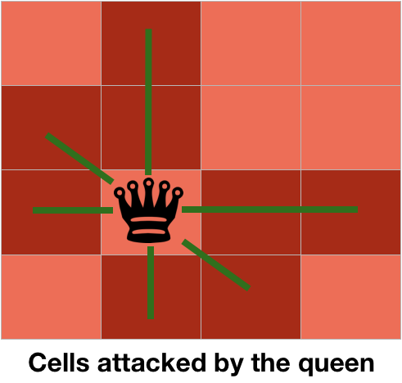
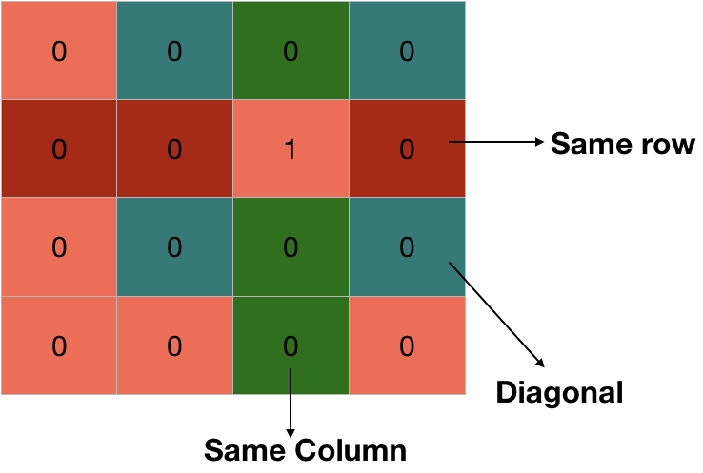

State Space for 4 Queens problem
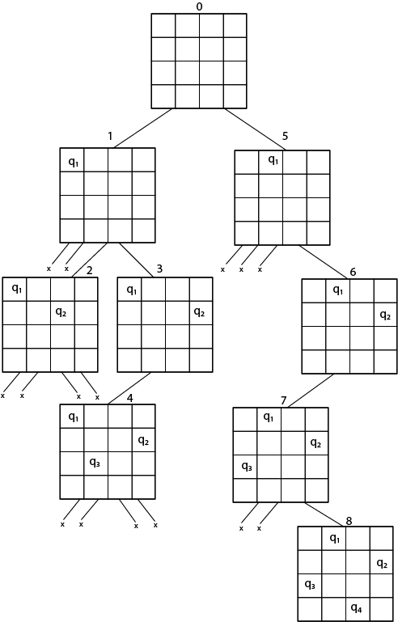

Solution :
- Q1-2,Q2- 4,Q3- 1,Q4- 3
- Q1-3,Q2-1,Q3-4,Q4-2

Algorithm:
IS-ATTACK(i, j, board, N)
// checking in the column j
for k in 1 to i-1
if board[k][j]==1
return TRUE
// checking upper right diagonal
k = i-1
l = j+1
while k>=1 and l<=N
if board[k][l] == 1
return TRUE
k=k+1
l=l+1
// checking upper left diagonal
k = i-1
l = j-1
while k>=1 and l>=1
if board[k][l] == 1
return TRUE
k=k-1
l=l-1
return FALSE
N-QUEEN(row, n, N, board)
if n==0
return TRUE
for j in 1 to N
if !IS-ATTACK(row, j, board, N)
board[row][j] = 1
if N-QUEEN(row+1, n-1, N, board)
return TRUE
board[row][j] = 0 //backtracking, changing current decision return FALSE

(i--,j--)(Upper left Diagonal)
(i,j)
(Queen Position)
(i++,j--)(Bottom right diagonal)

N Queen Problem using Branch And Bound
The N queens puzzle is the problem of placing N chess queens on an N×N chessboard so that no two queens threaten each other. Thus, a solution requires that no two queens share the same row, column, or diagonal.

In the backtracking solution we backtrack when we hit a dead end. In the Branch and Bound solution, after building a partial solution, we figure out that there is no point going any deeper as we are going to hit a dead end.

Let’s begin by describing a backtracking solution. “The idea is to place queens one by one in different columns, starting from the leftmost column. When we place a queen in a column, we check for clashes with already placed queens. In the current column, if we find a row for which there is no clash, we mark this row and column as part of the solution. If we do not find such a row due to clashes, then we backtrack and return false.”

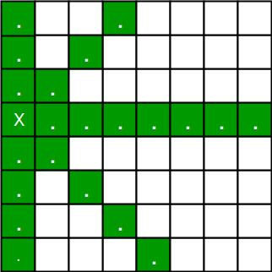
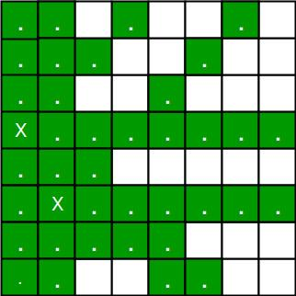

- For the 1st Queen, there are a total 8 possibilities as we can place the 1st Queen in any row of the first column. Let’s place Queen 1 on row 3.

- After placing 1st Queen, there are 7 possibilities left for the 2nd Queen. But wait, we don’t really have 7 possibilities. We cannot place Queen 2 on rows 2, 3 or 4 as those cells are under attack from Queen 1. So, Queen 2 has only 8 – 3 = 5 valid positions left.

- After picking a position for Queen 2, Queen 3 has even fewer options as most of the cells in its column are under attack from the first 2 Queens.

We need to figure out an efficient way of keeping track of which cells are under attack. In the previous solution we kept an 8 -by -8 Boolean matrix and updated it each time we placed a queen, but that required linear time to update as we needed to check for safe cells.
Basically, we have to ensure 4 things:
1. No two queens share a column.
2. No two queens share a row.
3. No two queens share a top-right to left-bottom diagonal.
4. No two queens share a top-left to bottom-right diagonal.
Number 1 is automatic because of the way we store the solution.
For number 2, 3 and 4, we can perform updates in O(1) time. The idea is to keep three Boolean arrays that tell us which rows and which diagonals are occupied.

Let's do some pre-processing first. Let’s create two N x N matrices one for / diagonal and other one for \ diagonal. Let’s call them slashCode and backslashCode respectively. The trick is to fill them in such a way that two queens sharing a same / diagonal will have the same value in matrix slashCode, and if they share same \ diagonal, they will have the same value in backslashCode matrix.
For an N x N matrix, fill slashCode and backslashCode matrix using below formula –
slashCode[row][col] = row + col
backslashCode[row][col] = row – col + (N-1)
Using above formula will result in below matrices
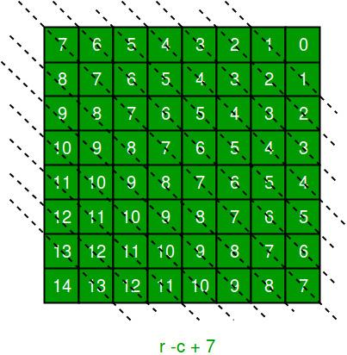

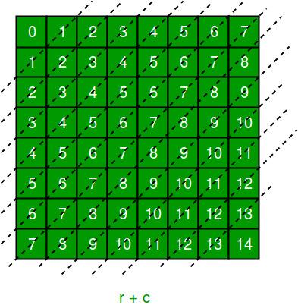
The ‘N – 1’ in the backslash code is there to ensure that the codes are never negative because we will be using the codes as indices in an array.
Now before we place queen i on row j, we first check whether row j is used (use an array to store row info). Then we check whether slash code ( j + i ) or backslash code ( j – i + 7 ) are used (keep two arrays that will tell us which diagonals are occupied). If yes, then we have to try a different location for queen i. If not, then we mark the row and the two diagonals as used and recurse on queen i + 1. After the recursive call returns and before we try another position for queen i, we need to reset the row, slash code and backslash code as unused again, like in the code from the previous
Time Complexity Analysis
1. the isPossible method takes O(n) time
2. for each invocation of loop in nQueenHelper, it runs for O(n) time
3. the isPossible condition is present in the loop and also calls nQueenHelper which is recursive adding this up, the recurrence relation is:
T(n) = O(n2) + n * T(n-1) solving the above recurrence by iteration or recursion tree, the time complexity of the nQueen problem is = O(N!)
CONCLUSION: Hence , We have Successfully implemented n queens problem using Backtracking and Branch and Bound Method

FAQS:
Q 1. Define the Constraint Satisfaction Problems. Describe the elements in the definition .
Answer: A constraint satisfaction problem (CSP) consists of:
• a set of variables {x1, x2, … xi};
• a finite set of domain D (possible values) associated with each variable;
• A set of constraints C restricting the values that the variables can simultaneously take CSP is to assign values to variables so that all constraints are satisfied.
Variables represent the entities in the constraint satisfaction problems.The domain of a variable is a set of possible values that can be assigned to the variable. Constraint is a set of relations upon domains of variables. A constraint on a set of variables restricts the values the variables can simultaneously take. It says what values are (dis-)allowed among the variables.

Q 2. Present a model for the n-queen problem. List what variables are needed for the problem , their domains , and show how constraints can be presented.
Model 1
Variables: xi,j: 1, if there is a queen in (i,j)
Domain: xi,j = {0, 1}
Constraint: list explicitly the invalid values for each pair of variables.
Model 2
Variables: x1, …, xn: position of queens on board
Domain: {1 … n2 }: tile index of each queen
Constraints: calculate the row (R) and column (C) index.
Given R1, R2 and C1, C2 of two queens’ positions
R1 ≠ R2, C1 ≠ C2, and R1 – R2 ≠ C1 – C2, R1 – R2 ≠ C2 – C1
Model 3
Variables: x1, …, xn: rows of the chessboard
Domain: {1 … n}: column index of each queen placed
Constraints: for all i, j = {1, …, n}, xi ≠ xj, xi - xj ≠ i - j & xi - xj ≠ j – i)

Q 3: Use an example to define the map coloring problem as a Constraint Satisfaction Problem.

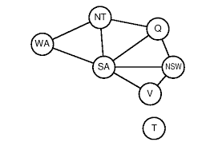
An example is given here to present a possible answer. Marks are given for any answers addressing the question. For the map coloring problem on the left:
Variables: {WA, NT, Q, SA, NSW, VIC, T}
Domains: {red, green, blue}
Constraints: {not_same(WA,NT), not_same(WA, SA), not_same(NT,SA), …}

Q 4. Explain why depth-first search is used in the search tree for Constraint Satisfaction Problems. Compare it with breadth-first search.
Answer: The solutions of CSP in a search tree will always be on the nth level.
If we use the breadth-first search, which searches all the nodes on the current level before it goes to the next level, the quickest it may find a solution will be after it finishes all the nodes on the 1st to the (n-1)th level.
Using depth first search, there is a chance that the search may find a solution the first time it goes down to the nth level. Although this does not often happen, the chance of finding a solution quicker is still much higher than that of breadth-first search.

Q 5. Present the pseudo-code of Generate and Test technique for constraint satisfaction problems
Explain briefly the basic idea behind it
Answer:
Repeat
Select the next variable
Assign a value to the variable
If current assignment leads to a failure (dead-end: no values are consistent with previous values)
Backtrack (replace the value assigned for previous variable with a new value)
Until a (no) complete solution is found
Generate and Test technique enumerates all possible combinations of values for variables one by one and sees if they satisfy all constraints.

Assignment No. 5

TITLE: Develop an elementary chatbot for any suitable customer interaction application.
OBJECTIVE: To learn and apply various search strategies for AI
OUTCOME: Design a system using different informed search / uninformed search or heuristic approaches
THEORY:
A chatbot can be defined as a developed program capable of having a discussion/conversation with a human. Any user might, for example, ask the bot a question or make a statement, and the bot would answer or perform an action as necessary. A chatbot communicates similarly to instant messaging.
A chatbot is software that simulates human conversations. It enables the communication between a human and a machine, which can take the form of messages or voice commands. A chatbot is designed to work without the assistance of a human operator. AI chatbot responds to questions posed to it in natural language as if it were a real person. It responds using a combination of pre-programmed scripts and machine learning algorithms.
When asked a question, the chatbot will answer using the knowledge database that is currently available to it. If the conversation introduces a concept it isn’t programmed to understand; it will pass it to a human operator. It will learn from that interaction as well as future interactions in either case. As a result, the scope and importance of the chatbot will gradually expand.

Working of Chatbot:
Bots are made for a specific reason. A store would most likely want chatbot services that assists you in placing an order, while a telecom company will want to create a bot that can address customer service questions.
There are two categories of chatbots: one that works by following a series of rules, and another that uses artificial intelligence.

1. Rule-based chatbots
A rule-based bot can only comprehend a limited range of choices that it has been programmed with. Predefined rules define the course of the bot’s conversation. Rule-based chatbots are easier to build as they use a simple true-false algorithm to understand user queries and provide relevant answers.

2. AI-based chatbots
This bot is equipped with an artificial brain, also known as artificial intelligence. It is trained using machine-learning algorithms and can understand open-ended queries. Not only does it comprehend orders, but it also understands the language. As the bot learns from the interactions it has with users, it continues to improve. The AI chatbot identifies the language, context, and intent, which then reacts accordingly.

Component of Chatbot:
Chatbot architecture is the spine of the chatbot. The type of architecture for your chatbot depends on various factors like use-case, domain, chatbot type, etc. However, the basic conversation flow remains the same. Let us learn more about the critical components of chatbot architecture:

1. Question and Answer System
As the name suggests, the Q&A system is responsible for answering customers’ frequently asked questions. The question is interpreted by the Q&A system, which then replies with appropriate responses from the knowledge base. It consists of the following elements:
- Manual Training: Manual training entails the domain specialist compiling a list of commonly asked user questions and mapping out the answers. It enables the chatbot to identify the most relevant questions’ answers rapidly.
- Automated Training: Automated training entails sending business documents to the chatbot, such as policy documents and other Q&A type documents, and instructing it to train itself. From these documents, the engine generates a list of questions and responses. The chatbot would then be able to respond with confidence.

2. Environment
The environment is mainly responsible for contextualizing users’ messages using natural language processing (NLP).
The NLP Engine is the central component of the chatbot architecture. It interprets what users are saying at any given time and turns it into organized inputs that the system can process. The NLP engine uses advanced machine learning algorithms to determine the user’s intent and then match it to the bot’s supported intents list.
NLP Engine has two components:
- Intent Classifier: An intent classifier maps between what a user asks and the type of action performed by the software.
- Entity Extractor: The entity extractor is responsible for identifying keywords from the user’s query that helps determine what the user is looking for.
An NLP engine can also be extended to include feedback mechanism and policy learning for better overall learning of the NLP engine.
- Feedback Mechanism: This includes the feedback for the chatbot provided by the users. This part of learning can be incorporated into the chatbot itself. Here, the user rates the interaction at the end of the conversation. It encourages the bot to learn from its mistakes and improve in future interactions.
- Policy Learning: Policy learning is a broad framework wherein the bot is trained to create a network of happy paths in the conversation flow that increase overall end-user satisfaction.

3. Front-End Systems
Front-end systems are the ones where users interact with the chatbot. These are client-facing systems such as – Facebook Messenger, WhatsApp Business, Slack, Google Hangouts, your website or mobile app, etc.

4. Node Server / Traffic Server
It is the server that deals with user traffic requests and routes them to the proper components. The response from internal components is often routed via the traffic server to the front-end systems.

5. Custom Integrations
With custom integrations, your chatbot can be integrated with your existing backend systems like CRM, database, payment apps, calendar, and many such tools, to enhance the capabilities of your chatbot.

CONCLUSION: Hence,We have successfully implemented Customer interactive chatbot.
FAQS:

Q 1. Knowledge engineering in FOL
Answer:
- Identify the task
- Assemble the relevant knowledge
- Decide on a vocabulary of predicates, functions, and constants
- Encode general knowledge about the domain
- Ecode a description of the specific problem instance
- Pose queries to the inference procedure and get answers
- Debug the knowledge base

Q 2. With an example, show objects, properties, functions and relations.
Answer:
Example “EVIL KING JOHN BROTHER OF RICHARD RULED ENGLAND IN 1200” Objects : John, Richard, England, 1200
Relation : Ruled
Properties : Evil, King
Functions : BROTHER OF

Q 3. Write PEAS description of Wumpus world
To explain the Wumpus world we have given PEAS description as below:
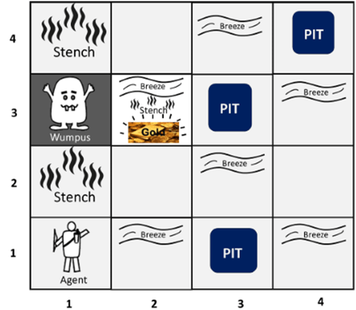
Performance measure:
+1000 reward points if the agent comes out of the cave with the gold.
-1000 points penalty for being eaten by the Wumpus or falling into the pit.
-1 for each action, and -10 for using an arrow.
The game ends if either agent dies or comes out of the cave.
Environment:
A 4*4 grids of rooms.
The agent initially in room square [1, 1], facing toward the right.
Location of Wumpus and gold are chosen randomly except the first square [1,1].
Each square of the cave can be a pit with probability 0.2 except the first square.
Actuators:
Left turn, Right turn, Move forward ,Grab ,Release, Shoot.
Sensors:
The agent will perceive the stench if he is in the room adjacent to the Wumpus. (Not diagonally).
The agent will perceive a breeze if he is in the room directly adjacent to the Pit.
The agent will perceive the glitter in the room where the gold is present.
The agent will perceive the bump if he walks into a wall.
When the Wumpus is shot, it emits a horrible scream which can be perceived anywhere in the cave.
These precepts can be represented as a five element list, in which we will have different indicators for each sensor.
Example if agent perceives stench, breeze, but no glitter, no bump, and no scream then it can be represented as:
[Stench, Breeze, None, None, None].

Q 4. What are the different types of Inference rules:

1. Modus Ponens:
The Modus Ponens rule is one of the most important rules of inference, and it states that if P and P → Q is true, then we can infer that Q will be true. It can be represented as:
Example:
Statement-1: "If I am sleepy then I go to bed" ==> P→ Q
Statement-2: "I am sleepy" ==> P
Conclusion: "I go to bed." ==> Q.
Hence, we can say that, if P→ Q is true and P is true then Q will be true.
Proof by Truth table:
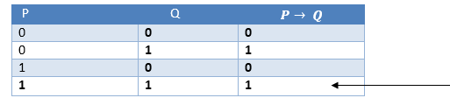

2. Modus Tollens:
The Modus Tollens rule states that if P→ Q is true and ¬ Q is true, then ¬ P will also be true. It can be represented as:
Statement-1: "If I am sleepy then I go to bed" ==> P→ Q
Statement-2: "I do not go to the bed."==> ~Q
Statement-3: Which infers that "I am not sleepy" => ~P
Proof by Truth table:
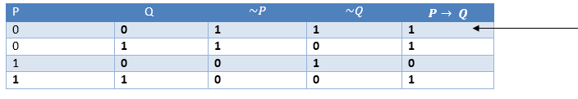

3. Hypothetical Syllogism:
The Hypothetical Syllogism rule states that if P→R is true whenever P→Q is true, and Q→R is true. It can be represented as the following notation:
Example:
Statement-1: If you have my home key then you can unlock my home. P→Q
Statement-2: If you can unlock my home then you can take my money. Q→R
Conclusion: If you have my home key then you can take my money. P→R
Proof by truth table:
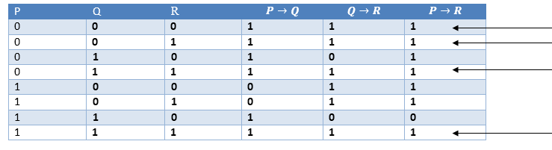

4. Disjunctive Syllogism:
The Disjunctive syllogism rule state that if P∨Q is true, and ¬P is true, then Q will be true. It can be represented as:
Example:
Statement-1: Today is Sunday or Monday. ==>P∨Q
Statement-2: Today is not Sunday. ==> ¬P
Conclusion: Today is Monday. ==> Q
Proof by truth-table:
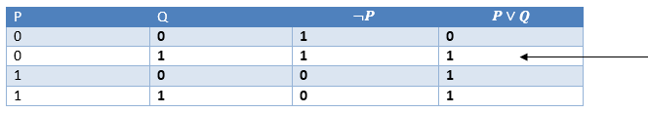

5. Addition:
The Addition rule is one the common inference rule, and it states that If P is true, then P∨Q will be true.
Example:
Statement: I have a vanilla ice-cream. ==> P
Statement-2: I have Chocolate ice-cream.
Conclusion: I have vanilla or chocolate ice-cream. ==> (P∨Q)
Proof by Truth-Table:
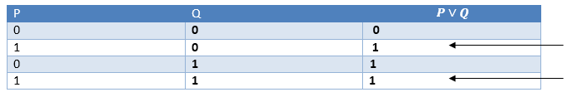

6. Simplification:
The simplification rule state that if P∧ Q is true, then Q or P will also be true. It can be represented as:
Proof by Truth-Table:
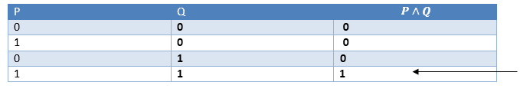

7. Resolution:
The Resolution rule state that if P∨Q and ¬ P∧R is true, then Q∨R will also be true. It can be represented as
Proof by Truth-Table:
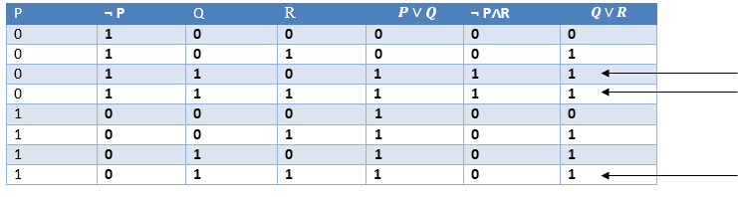

Q 5: Write application of Artificial Intelligence in Healthcare
Answer: Artificial Intelligence (AI) is transforming industries around the world, and currently, its application is rapidly increasing in the healthcare sector. AI in healthcare describes the use of AI or machine-learning algorithms to mimic human cognition for gathering and understanding complex medical and health care data.AI does this by various Machine Learning algorithms, Computer Vision, Natural Language Processing, Robotics, and Deep Learning. These algorithms recognize a pattern in behavior and then create their own logic to give well-defined output to end-users. Machine Learning helps to gain important insights and predictions using extensive amounts of input data. Further, they also instruct experts on how to build companions for expensive clinical preliminaries.

Assignment No. 6
TITLE: Implement Expert System for Hospitals and medical facilities
OBJECTIVE: To learn and apply various search strategies for AI
OUTCOME: Design a system using different informed search / uninformed search or heuristic approaches
THEORY:
A system that uses human expertise to make complicated decisions. Simulates reasoning by applying knowledge and interfaces. Uses expert’s knowledge as rules and data within the system. Model the problem solving ability of a human expert.
Components of an ES:
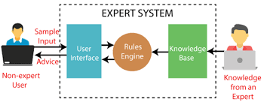
Knowledge Base
- Represents all the data and information imputed by experts in the field.
- Stores the data as a set of rules that the system must follow to make decisions.
Reasoning or Inference Engine
- Ask the user questions about what they are looking for.
- Applies the knowledge and the rules held in the knowledge base.
- Appropriately uses this information to arrive at a decision.
User Interface
- Allows the expert system and the user to communicate.
- Find out what it is that the system needs to answer.
- Sends the user questions or answers and receives their response.
Key Features:
- Unification: The basic idea is, can the given terms be made to represent the same structure.
- Backtracking: When a task fails, prolog traces backwards and tries to satisfy the previous task.
- Recursion: Recursion is the basis for any search in a program.

Algorithm:
1. First step for execution is to install SWI prolog on your machine.
2. Open the prolog editor.
3. Run using go. Command.
?- go.
• Does the patient have a headache? : y.
• Does the patient has the symptom runny nose? : |: n.
• Does the patient have a sore throat? : |: n.
• Does the patient has the symptom abdominal pain? : |: y.
• Does the patient have symptoms of poor appetite? : |: y.
• Does the patient have the symptom fever? : |: y.
• Advices and Suggestions:
1: Chloramphenicol
2: Amoxicillin
3: Ciprofloxacin
4: Azithromycin
Please do complete bed rest and take soft diet because
It is suggested that the patient has typhoid
true.
CONCLUSION: With the help of options we can elaborate the linux command successfully.
FAQS:

Q 1. Describe types of Knowledge representation?
There are four types of Knowledge representation : Relational, Inheritable, Inferential, and Declarative/Procedural.
Relational Knowledge : provides a framework to compare two objects based on equivalent attributes. any instance in which two different objects are compared is a relational type of knowledge.
Inheritable Knowledge − is obtained from associated objects. − it prescribes a structure in which new objects are created which may inherit all or a subset of attributes from existing objects.
Inferential Knowledge − is inferred from objects through relations among objects. − e.g., a word alone is a simple syntax, but with the help of other words in a phrase the reader may infer more from a word; this inference within linguistics is called semantics.
Declarative Knowledge − a statement in which knowledge is specified, but the use to which that knowledge is to be put is not given. − e.g. laws, people's name; these are facts which can stand alone, not dependent on other knowledge; Procedural Knowledge − a representation in which the control information, to use the knowledge, is embedded in the knowledge itself. − e.g. computer programs, directions, and recipes; these indicate specific use or implementation

Q 2. Discuss in details about inferential knowledge?
This knowledge generates new information from the given information. This new information does not require further data gathering from soue, but does require analysis of the given information to generate new knowledge.
− given a set of relations and values, one may infer other values or relations.
− a predicate logic (a mathematical deduction) is used to infer from a set of attributes.
− inference through predicate logic uses a set of logical operations to relate individual data.
− the symbols used for the logic operations are :
" → " (implication), " ¬ " (not), " V " (or), " Λ " (and), " ∀ " (for all), " ∃ " (there exists).
Examples of predicate logic statements :
1. "Wonder" is a name of a dog : dog (wonder)
2.All dogs belong to the class of animals : ∀ x : dog (x) → animal(x)
3.All animals either live on land or in ∀ x : animal(x) → live (x,water : land) V live (x, water)
From these three statements we can infer that :
" Wonder lives either on land or on water."

Q 3. Discuss about Predicate Logic ?
Predicate Logic
The propositional logic, is not powerful enough for all types of assertions;
Example : The assertion "x > 1", where x is a variable, is not a proposition because it is neither true nor false unless the value of x is defined. For x > 1 to be a proposition ,
− either we substitute a specific number for x ;
− or change it to something like "There is a number x for which x > 1 holds";
− or "For every number x, x > 1 holds".
Consider example :
“ All men are mortal.
Socrates is a man.
Then Socrates is mortal” ,
These cannot be expressed in propositional logic as a finite and logically valid argument (formula). We need languages : that allow us to describe properties ( predicates ) of objects, or a relationship among objects represented by the variables . Predicate logic satisfies the requirements of a language.
− Predicate logic is powerful enough for expression and reasoning.
− Predicate logic is built upon the ideas of propositional logic.
Predicate :
Every complete "sentence" contains two parts : a "subject" and a "predicate". The subject is what (or whom) the sentence is about. The predicate tells something about the subject;
Example : A sentence "Judy {runs}".
The subject is Judy and the predicate is run . Predicate, always includes verbs, tells something about the subject. Predicate is a verb phrase template that describes a property of objects, or a relation among objects represented by the variables.
Example: “The car Tom is driving is blue"; "The sky is blue" ;"The cover of this book is blue" Predicate is “is blue" , describes property.
Predicates are given names; Let „B‟ is the name for the predicate "is_blue". Sentence is represented as "B(x)" , read as "x is blue"; “x” represents an arbitrary Object .

Q 4. Define Atomic sentences.
Atomic sentences are formed by both objects and relations.
Example Brother (William, Richard)
William is the brother of Richard.

Q 5. Define Modus Ponens rule in Propositional logic?
The standard patterns of inference that can be applied to derive chains of conclusions that lead to the desired goal is said to be Modus Ponens rule.

Q 6.Define AND –Elimination rule in propositional logic
AND elimination rule states that from a given conjunction it is possible to inference any of the conjuncts. OR-Introduction rule states that from a sentence, we can infer its disjunction with anything.

Q 7. Explain Google Maps and Ride-Hailing Applications
Answer: Traveling to a new destination does not require much thought any longer. Rather than relying on confusing address directions, we can now easily open our phone's map app and type in our destination.
So how does the app know about the appropriate directions, best way, and even the presence of roadblocks and traffic jams? A few years ago, only GPS (satellite-based navigation) was used as a navigation guide. However, artificial intelligence (AI) now provides users with a much better experience in their unique surroundings.
The app algorithm uses machine learning to recall the building's edges that are supplied into the system after the person has manually acknowledged them. This enables the map to provide simple visuals of buildings. Another feature is identifying and understanding handwritten house numbers, which assists
travelers in finding the exact house they need. Their outline or handwritten label can also recognize locations that lack formal street signs.
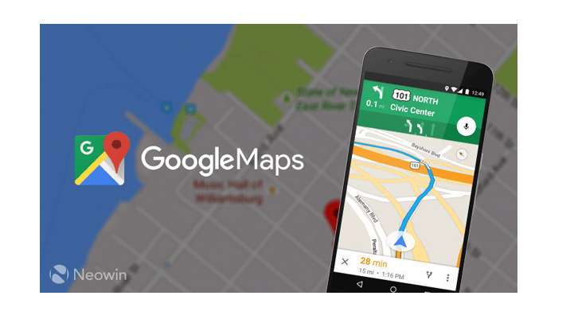
The application has been trained to recognize and understand traffic. As a result, it suggests the best way to avoid traffic congestion and bottlenecks. The AI-based algorithm also informs users about the precise distance and time it will take them to arrive at their destination. It has been trained to calculate this based on the traffic situations. Several ride-hailing applications have emerged as a result of the use of similar AI technology. So, whenever you need to book a cab via an app by putting your location on a map, this is how it works.

Assignment No. 7
TITLE: Implement Tic-Tac -Toe using Min max Algorithm
OBJECTIVE: To learn and apply various search strategies for AI
OUTCOME: Design a system using different informed search / uninformed search or heuristic approaches
THEORY:
- Mini-max algorithm is a recursive or backtracking algorithm which is used in decision-making and game theory. It provides an optimal move for the player assuming that the opponent is also playing optimally.
- The Mini-Max algorithm uses recursion to search through the game-tree.
- The Min-Max algorithm is mostly used for game playing in AI. Such as Chess, Checkers, tic-tac-toe, go, and various two-players games. This Algorithm computes the minimax decision for the current state.
- In this algorithm two players play the game, one is called MAX and other is called MIN.
- Both the players fight it as the opponent player gets the minimum benefit while they get the maximum benefit.
- Both Players of the game are opponents of each other, where MAX will select the maximized value and MIN will select the minimized value.
- The minimax algorithm performs a depth-first search algorithm for the exploration of the complete game tree.
- The minimax algorithm proceeds all the way down to the terminal node of the tree, then backtrack the tree as the recursion.

MinMax Algorithm:
- function minimax(node, depth, maximizingPlayer) is
- if depth ==0 or node is a terminal node then
- return static evaluation of node
- if MaximizingPlayer then // for Maximizer Player
- maxEva= -infinity
- for each child of node do
- eva= minimax(child, depth+1, false)
- maxEva= max(maxEva,eva) //gives Maximum of the values
- return maxEva
- else // for Minimizer player
- minEva= +infinity
- for each child of node do
- eva= minimax(child, depth+1, true)
- minEva= min(minEva, eva) //gives minimum of the values
- return minEva

Working of Min-Max Algorithm:
- The working of the minimax algorithm can be easily described using an example. Below we have taken an example of game-tree which is representing the two-player game.
- In this example, there are two players one is called Maximizer and other is called Minimizer.
- Maximizer will try to get the Maximum possible score, and Minimizer will try to get the minimum possible score.
- This algorithm applies DFS, so in this game-tree, we have to go all the way through the leaves to reach the terminal nodes.
- At the terminal node, the terminal values are given so we will compare those values and backtrack the tree until the initial state occurs. Following are the main steps involved in solving the two-player game tree:
Step-1: In the first step, the algorithm generates the entire game-tree and applies the utility function to get the utility values for the terminal states. In the below tree diagram, let's take A as the initial state of the tree. Suppose maximizer takes the first turn which has worst-case initial value =- infinity, and minimizer will take next turn which has worst-case initial value = +infinity.
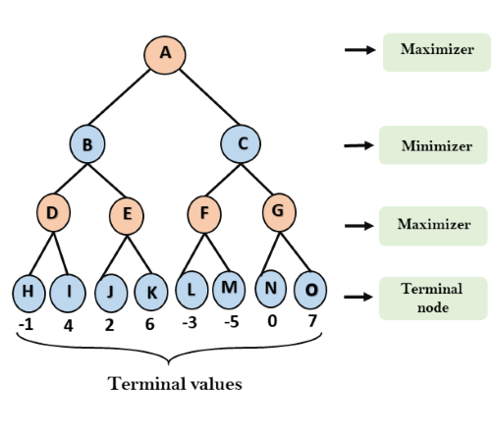
Step 2: Now, first we find the utility value for the Maximizer, its initial value is -∞, so we will compare each value in terminal state with the initial value of Maximizer and determine the higher nodes values. It will find the maximum among them all.
- For node D max(-1,- -∞) => max(-1,4)= 4
- For Node E max(2, -∞) => max(2, 6)= 6
- For Node F max(-3, -∞) => max(-3,-5) = -3
- For node G max(0, -∞) = max(0, 7) = 7
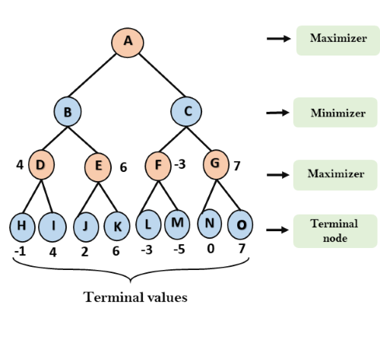
Step 3: In the next step, it's a turn for minimizer, so it will compare all node values with +∞, and will find the 3rd layer node values.
- For node B= min(4,6) = 4
- For node C= min (-3, 7) = -3
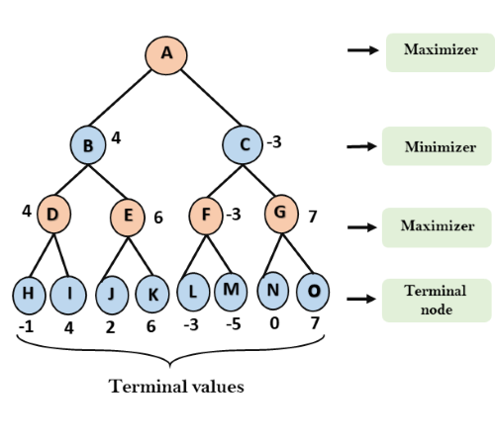
Step 4: Now it's a turn for Maximizer, and it will again choose the maximum of all node values and find the maximum value for the root node. In this game tree, there are only 4 layers, hence we reach immediately to the root node, but in real games, there will be more than 4 layers.
- For node A max(4, -3)= 4
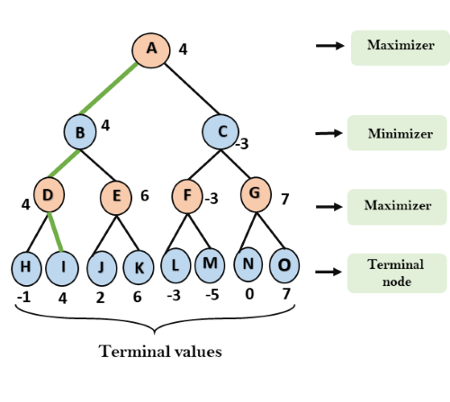
That was the complete workflow of the minimax two player game.

Properties of Min-Max algorithm:
- Complete- Min-Max algorithm is Complete. It will definitely find a solution (if it exists), in the finite search tree.
- Optimal- Min-Max algorithm is optimal if both opponents are playing optimally.
- Time complexity- As it performs DFS for the game-tree, so the time complexity of Min-Max algorithm is O(bm), where b is the branching factor of the game-tree, and m is the maximum depth of the tree.
- Space Complexity- Space complexity of Min-max algorithm is also similar to DFS which is O(bm).
Steps: Tic-Tac-Toe – Finding optimal move

Finding the Best Move :
findBestMove() function evaluates all the available moves using minimax() and then returns
the best move the maximizer can make.
function findBestMove(board):
bestMove = NULL
for each move in board :
if current move is better than bestMove
bestMove = current move
return bestMove

Checking for GameOver state
To check whether the game is over and to make sure there are no moves left use isMovesLeft()
function. It is a simple straightforward function which checks whether a move is available or
not and returns true or false respectively.
function isMovesLeft(board):
for each cell in board:
if current cell is empty:
return true
return false

Making Tic-Tac-Toe smarter:
One final step is to make AI a little bit smarter. Even though the following AI plays perfectly,
it might choose to make a move which will result in a slower victory or a faster loss.
Assume that there are 2 possible ways for X to win the game from a given board state.
• Move A : X can win in 2 move
• Move B : X can win in 4 moves
Evaluation function will return a value of +10 for both moves A and B. Even though the move
A is better because it ensures a faster victory, our AI may choose B sometimes. To overcome
this problem subtract the depth value from the evaluated score. This means that in case of a
victory it will choose a the victory which takes least number of moves and in case of a loss it
will try to prolong the game and play as many moves as possible. So the new evaluated value
will be
• Move A will have a value of +10 – 2 = 8
• Move B will have a value of +10 – 4 = 6
Now since move A has a higher score compared to move B. AI will choose move A over move
B. The same thing must be applied to the minimizer. Instead of subtracting the depth add the
depth value as the minimizer always tries to get, as negative a value as possible.
if maximizer has won:
return WIN_SCORE – depth
else if minimizer has won:
return LOOSE_SCORE + depth

CONCLUSION: With the help of options we can elaborate the linux command successfully.
FAQS:

Q 1. What is game playing?
Answer:
The term Game means a sort of conflict in which n individuals or groups (known as players) participate. Game theory denotes games of strategy. Game theory allows decision-makers (players) to cope with other decision-makers (players) who have different purposes in mind. In other words, players determine their own strategies in terms of the strategies and goals of their opponent.

Q 2. What is Mini –Max Strategy?
Answer:
• generate the whole game tree , calculate the value of each terminal state
• based on the utility function - calculate the utilities of the higher level nodes
• starting from the leaf nodes up to the root
-MAX selects the value with the highest node
-MAX assumes that MIN in its move will select the node that minimizes the value from MAX’s perspective
• MAX tries to move to a state with the maximum value, MIN to one with the minimum assumes that both players play optimally
selects the best successor from a given state , invokes MINIMAX-VALUE for each successor state

Q 3. Define pruning?
Answer:
Alpha–beta pruning is a search algorithm that seeks to decrease the number of nodes that are evaluated by the minimax algorithm in its search tree. It is an adversarial search algorithm used commonly for machine playing of two-player games (Tic-tac-toe, Chess, Go, etc.). It stops completely evaluating a move when at least one possibility has been found that proves the move to be worse than a previously examined move.

Q 4. What do you mean by adversarial search
Answer:
Adversarial search is a search, where we examine the problem which arises when we try to plan ahead of the world and other agents are planning against us.
- The environment with more than one agent is termed a multi-agent environment, in which each agent is an opponent of another agent and playing against each other. Each agent needs to consider the action of another agent and the effect of that action on their performance.
- So, Searches in which two or more players with conflicting goals are trying to explore the same search space for the solution, are called adversarial searches, often known as Games.
- Games are modeled as a Search problem and heuristic evaluation function, and these are the two main factors which help to model and solve games in AI.

Q 5. What are the different types of games?

Answer:

Types of Games in AI:
Type | Deterministic | Chance Moves
Perfect information | Chess, Checkers, go, Othello | Backgammon, monopoly
Imperfect information | Battleships, blind, tic-tac-toe | Bridge, poker, scrabble, nuclear war
- Perfect information: A game with the perfect information is that in which agents can look into the complete board. Agents have all the information about the game, and they can see each other's moves also. Examples are Chess, Checkers, Go, etc.
- Imperfect information: If in a game agents do not have all information about the game and are not aware of what's going on, such types of games are called the game with imperfect information, such as tic-tac-toe, Battleship, blind, Bridge, etc.

